­



PROGRAM BOOK

COMMUNITY SERVICE PROJECT

COMMUNITY SERVICE PROJECT

AP STATE COUNCIL OF HIGHER EDUCATION

(A STATUTORY BODY OF GOVERNMENT OF ANDHRA PRADESH)

**PROGRAM BOOK FOR**

**COMMUNITY SERVICE PROJECT**

**Name of the Student : Bommu Lakshmi Prasanna**

**Name of the College : Narasaraopeta Engineering College**

**Period of CSP :** 29-05-2023 to 24-06-2023

**Name of the Community :** Career Building Guidelines

**Address of the Habitation : Narasaraopet**

**COMMUNITY SERVICE PROJECT REPORT ON**

**AWARENESS ON CAREER BUILDING GUIDELINES**

**Submitted in accordance with requirement of the degree of B. Tech-CSE**

|  |  |
| --- | --- |
| **Name of the College** | **:** Narasaraopeta Engineering College |
| **Department** | **:** Computer Science and Engineering |

**Name of the Faculty Guide : DrJhansi Vazram**

|  |  |
| --- | --- |
| **Duration of the CSP** | **:** From: 29-05-2003 To: 24-06-2003 |
| **Name of the student** | **:** Bommu Lakshmi Prasanna |
| **Program of Study** | **:** Computer Science and Engineering |
|  |  |
| **Year of Study** | **:** 3rd Year |
| **Roll Number** | **:** 21471A0513 |
| **Date of Submission** | **:** |

## Student’s Declaration

I,Bommu Lakshmi Prasanna, a student of B. Tech. Program, Reg. No. 21471A0513 of the Department of Computer Science and Engineering, Narasaraopeta Engineering college do hereby declare that, I have completed the mandatory Community Service Project at Narasaraopeta from

29-05-2023 to 24-06-2023 on “Awareness on Career Building Guidelines” under the Faculty Guideship of Dr Jhansi Vazram Madam (Professor), Department of Computer Science and Engineering in Narasaraopeta Engineering College

.

(Signature of the Student and Date)

### Endorsements

Faculty Guide

Head of the Department

Principal

## Certificate from Official of the Community

This is to certify that Bommu Lakshmi Prasanna**,** Registration.No. 21471A0513 from the Department of Computer Science and Engineering, Narasaraopeta Engineering College underwent community Service on career Building Guidelines from29-05-2023 to 24-06-2023 The overall performance of the Community Service Project Volunteer during his Community Service Project is found to be satisfactory

Authorized Signatory with Date and Seal

## Acknowledgements

We wish to express my thanks to various personalities who are responsible for completion of this project. We are extremely thankful to our beloved chairman Sri **M.V. Koteswara Rao, B.Sc.,** who took keen interest in us in every effort throughout this course. We owe our sincere gratitude to our beloved principal sir

**Dr.M. Sreenivasa Kumar, MTech., Ph.D., MISTE, FIE(I),** for showing his kind attention and valuable guidance throughout the course

We express our deep-felt gratitude towards **Dr. S.N Tirumala Rao, M. Tech. Ph.D. HOD of CSE** Department

and also, to our guide **Dr Jhansi Vazram madam,** Prof of CSE Department whose valuable guidance and

unstinting encouragement enable us to accomplish our project successfully in time. We extend our sincere thanks to all other teaching and non-teaching staff to department for their cooperation and encouragement during our Community Service Project.

We affectionately acknowledge the encouragement received from our friends and those who involved in giving valuable suggestions had clarifying our doubts which had really helped us in successfully completing our Community Service Project

. PROJECT ASSOCIATES:

Bommu Lakshmi Prasanna (21471A0513)

Divvela Bala Sri Abhigna (21471A0519)

Borugadda Supriya (21471A0514)

Gude Lavanya (21471A0524)

Karasala Deepika (21471A0518)

Dasari Triveni (21471A0517)

Pandi Jyoshna (21471A0542)

Nakka Annapurna (21471A0538)

Narra Divya (21471A0540)

**INDEX**

|  |  |  |
| --- | --- | --- |
| **S. No** | **CONTENTS** | **PAGE**  **No.** |
| **1.** | CHAPTER-1 EXECUTIVE SUMMARY | 7 |
| **2.** | CHAPTER-2 OVERVIEW OF THE COMMUNITY | 8 |
| **3.** | CHAPTER-3 COMMUNITY SERVICE PART | 9 |
| **4.** | CHAPTER-4 ACTIVITY LOGBOOK | 11 |
| **5.** | CHAPTER-5 OUTCOMES DESCRIPTION | 22 |
| **6.** | SURVEY QUESTIONS | 28 |
| **7.** | PROBLEMS IDENTIFIED IN THE COMMMUNITY | 29 |
| **8.** | SHORT TERM AND LONG-TERM ACTION PLANS | 33 |
| **9.** | REPORT OF THE CSP | 36 |
| **10.** | CHAPTER-6 RECOMMENDATIONS & CONCLUSIONS OF THE CSP | 37 |
| **11.** | STUDENT SELF EVALUATION | 39 |
| **12.** | EVALUATION BY PERSON IN-CHARGE | 40 |
| **13.** | PHOTOS | 41 |
| **14.** | SCREEN SHOTS | 53 |

## CHAPTER 1: EXECUTIVE SUMMARY

The Career Building Guidelines, which has been conducted on period of May29-05-23

To 24-06-23 in Narasaraopet requires an executive summary outlining a community service project focused on raising awareness about Career Building guidelines. The project aims to address the lack of awareness, engage community members, and encourage the High School Students to increase the view on their career after 10th standard.

### Methods:

* **Awareness Campaign:** Launch an extensive campaign using social media, print media, and community events to educate the local school students about the importance of career choosing paths after 10th class.
* **Education and Information Dissemination:** Organize workshops and seminars to provide detailed knowledge about the career paths a student can choose after 10 and importance of choosing a good career to their bright future.
* **Interaction with Schools:** collaborating with Schools to educate the 10th class students about future career plans and all the available courses after 10th class.
* **Collaborating With Students**: We interacted with the students about their interests and what is their goal to do in the future and explained about what are the available courses in after 10th class.
* **Community Engagement:** Encourage Students in Schools to increase knowledge about their future career paths and importance of choosing a good career path.
* our community service project aims to bring the knowledge among the students to choose a right career based on their interests and talents.

## CHAPTER 2: OVERVIEW OF THE COMMUNITY

### Report of the community service project work done in the related subject w.r.t the school/college.

The community service project on raising awareness of career building guidelines in Narasaraopet among students involved various activities and interactions with schools and many students.

2.1 **Formation and Topic Selection:**

Groups were formed, and after discussions, a topic was selected unanimously.

2.2 **Information Gathering and Presentation:**

Extensive research was conducted, and the findings were compiled into a PowerPoint presentation.

* 1. **Permission and Interaction at Narasaraopet Public School:**

Permission was obtained from the head and principal of the Narasaraopet public school. The school management gave us permission to our survey and interact with the students and also all the staff at the school also helped with our survey

* 1. **Expansion to Narasaraopet:**

The project extended to Narasaraopet nearby schools, where permission was granted to interact with the 10th class students to raise awareness about their career choosing after 10th standard.

2.5 **Positive Response and Knowledge Acquisition:**

The project received positive feedback from students, Principal sir of the school and all staff members. Valuable knowledge and insights were gained throughout the project.

Overall, the community service project successfully engaged students, raised awareness about career guidance, and received positive responses from both students, teachers and the from the school.

**CHAPTER 3: COMMUNITY SERVICE PART**

The community service project in Narasaraopet revolves around the high schools to know the details about the students’ problems to choose a right career after 10th. We recognise the importance of a guid to students for their future career development. So, we decided to bring awareness and a great knowledge to students about importance of career building after their high school and how it effects and helps to develop their future and settle well.

This project, we seek to create a culture of compassion and solidarity, where community members understand the impact of their contributions and actively participate in this awareness to increase the career building guidelines. By working together, we can make a tangible and positive impact on the well-being of our high school students.

**Objectives:**

The primary objective of our community service project is to raise awareness about the importance of Milk production. Recent study shows that India is the largest producer of milk in the world which is nearly 10% of the world production.

**Raise Awareness:**

The primary aim of our project is to raise awareness among 10th class and high school students to choose a good career path. That can help in development of their future and builds a life. Our main aim is educating students and guide the students to choose a good path after 10th based on their interests and their skills. And our main goal is to explain importance of career guidance and help out the students about their future studies and outcomes of every career path.

**What to choose After 10th Class:**

Class 10th is like a benchmark for every student. This is the first step towards a future career. The decisions made at this phase will shape your future. Are you in class 10 and confused about what’s after 10? This blog will clear all your doubts.

You have to make very crucial decisions regarding your streams as you have to choose between science, commerce, and arts. This will decide your career option and thus it will accordingly shape up your entire future.

In that respect career guidance after 10th becomes quite important. It not only helps in determining the right career options but also the right career path. Career Counselling platforms offers you the opportunity to communicate with the best **career counsellors** and understand what’s appropriate for you after 10th.

**Different Streams Available after class 10th:**

The most challenging decision that one has to make after completing class 10 is picking the right stream. It’s an extremely important step and everything that happens with you in your career depends on this decision. Often students tend to follow the herd mentality and choose the stream that most of their friends opt for or the one that their parents and relatives suggest.

These ways are not correct as that may lead to flawed career decisions. Therefore, you must make the decisions only after acquiring a proper understanding and knowledge about the streams and their related career captions. **Career guidance after 10th** is necessary for that situation. Before we proceed in further discussion, let’s further find out the streams that are available after class 10th.

Science Commerce

Arts/Humanities

Stream

Independent Courses

## Which board to choose after 10th:

Now, you have completed your 10th class, it’s the most difficult time as you have to make many informed decisions about your career. These decisions are going to influence your entire life. As already discussed, you have to make informed decisions regarding your stream. Besides that, you have to also decide on your board of study. Yes, the board too plays an important role in your career path.

 Each board has its own advantages and choosing the board depends upon your career goal. Most commonly, in India CBSE, ICSE, IB, and state boards are prevalent. Usually, state boards follow the syllabus of CBSE with slight amendments. When it’s about receiving the best knowledge and guidance after class 10 then selecting the right board and school becomes mandatory. Are you confused about which board is for you? **Career counselling for 10th students** helps in avoiding confusion and selecting the best option:

CBSE (Central Board of Secondary Education)

ICSE (Indian Certificate of Secondary Education)

## What are the career paths available for 10th students

The decisions regarding your stream, board, and future career options are some of the most crucial decisions of your life. You should never make this in a hurry or by getting influenced by somebody else’s decision. It’s always better that you opt for **career guidance after 10th** to get the right career guidance. However, before you consult experts, it’s important you are aware of the different career paths that you have after 10th.They are **Intermediate** **Polytechnic, Paramedical, ITI.**

**Other short-term courses**

Class 10 is considered the first step in your career so it is the time when you need to make the right career decision. A wrong decision at this step can either completely make or ruin your future. So, you should always opt for **career guidance after 10th**to gain information about all the options that you have after 10. Effective career guidance can do wonders for your future. Under an expert’s guidance, you can assess and analyse your strengths and weaknesses and make your career decisions accordingly.

**What next after 10th- Assessing and analysing your strengths and weaknesses**

It’s important to assess your interest and aptitude, and match up with the understanding of the requirements of the career. If you choose a stream merely based on your interests and do not possess the right skills and abilities, it may cause a problem in the future. So, to get a better idea for yourself about what is next after 10th, sit and introspect about what are the areas you are naturally good at, and what are those areas that are often hurdles for you. You may also take inputs from parents or teachers.

**What next after 10th- Seek Career Counselling**

The best and most reliable way to evaluate your strengths and weaknesses is to take an assessment with a professional [Career Counsellor](https://www.careers360.com/careers/counsellor), and select a stream based on the consensus you reach with them. For a successful career, a well-carved path and proper careful planning is a must. Career assessments and a professional Career Counsellor can guide you appropriately in choosing the best career options, and understand what is next after 10th class.

**What next after 10th- Some important tips to keep in mind**

Apart from focusing on choosing the right stream and subjects, it is also essential to keep working on yourself and building on skills that will prepare you for the immense competition in the job market. The more aware we are of what is happening around the world, the more we become ready to enter the industry. It is always beneficial to start early:

**Activities:**

**Informational Presentations:**

We will organize presentations in schools, community and public spaces to educate community members about the significance of career guidance. These sessions will cover topics such as the career choosing importance, and to get knowledge about the how to choose a good career after 10th.

**Career Counselling:**

Seek guidance from professional career counsellors who can assess your interests, aptitudes, and personality traits to suggest suitable career options.

**Aptitude Tests:**

Take aptitude tests to identify your strengths and weaknesses, helping you align your skills with potential career paths.

**Career Workshops and Seminars**:

Attend workshops and seminars organized by schools, colleges, or other institutions to explore various career options and hear from professionals in different fields.

# Conclusion:

Through our community service project, we hope to empower our community students with the knowledge and understanding of a correct career building. By dispelling misconceptions and inspiring a sense of responsibility towards others, we can build a culture of compassion and generosity. Together, let's take a step forward in improving the health and wellbeing of those in need and make a lasting impact on our community's future. Join us on this journey to awareness the students about career building, save lives, and create a stronger and more compassionate community.

**ACTIVITY LOG FOR THE FIRST WEEK**

|  |  |  |  |
| --- | --- | --- | --- |
| Day & Date | Brief  Description of The  Daily Activity | Learning  Outcome | Person  in Charge  Signature |
| MONDAY  &  29-05-23 | Future goals and their interests to do in future course service details from high school students | students learn  about them  interests of courses  and all possible  courses after 10th |  |
| TUESDAY  &  30-05-23 | Future goals and their interests to do in future course service details from high school students | students learn  about them  interests of courses  and all possible  courses after 10th |  |
| WEDNESDAY  &  31-05-23 | Future goals and their interests to do in future course service details from high school students | students learn  about them  interests of courses  and all possible  courses after 10th |  |
| THURSDAY  &  01-06-23 | Career guidance in schools | Awareness on  choosing  Career paths to  build a bright future |  |
| FRIDAY  &  02-06-23 | Career guidance in schools | Awareness on  choosing  Career paths to  build a bright future |  |
| SATURDAY  &  03-06-23 | Career guidance in schools | Awareness on  choosing  Career paths to  build a bright future |  |

**CHAPTER-4 ACTIVITY LOGBOOK ACTIVITY LOG FOR THE FIRST WEEK**

**WEEKLY REPORT**

## WEEK 1 (From Dt:29-05-23 To Dt:03-06-23)

**Objective of the activity done:**

The overall objective of the activities conducted during the first week is to raise awareness among students about their interests and all available list of courses after 10th

**Detailed report:**

In the very first week of the community service project “Career Building Guidlines”, the team has conducted socio and economic survey about student interests and giving a brief info about the list of courses they can choose after their 10th completion

The survey work was done up to 3 days of the week. The survey form included the details like whether they are interested what type of subjects and interests of the students among their studies after high school

For the remaining 3 days of the week, we conducted an awareness program about the career guidelines and more information on career guidelines and how it helps students

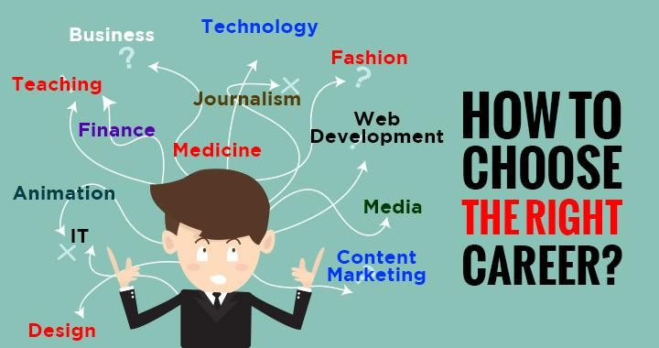

**ACTIVITY LOG FOR THE SECOND WEEK**

|  |  |  |  |
| --- | --- | --- | --- |
| Day Date | BriefDescription of TheDaily Activity | LearningOutcome | Person in ChargeSignature |
| MONDAY  &  05-06-23 | All Career paths you can choose after 10th | Knowledge on available courses |  |
| TUESDAY  &  06-06-23 | All Career paths you can choose after 10th | Knowledge on available courses |  |
| WEDNESDAY  &  07-06-23 | All Career paths you can choose after 10th | Knowledge on available courses |  |
| THURSDAY  &  08-06-23 | Career building guidance | Information on career guidance |  |
| FRIDAY  &  09-06-23 | Career building guidance | Information on career guidance |  |
| SATURDAY  &  10-06-23 | Career building guidance | Information on career guidance |  |

**CHAPTER-4 ACTIVITY LOGBOOK ACTIVITY LOG FOR THE SECOND WEEK**

## WEEK 2 (From Dt:05-06-23 To Dt:10-06-23)

**Objective of activity done:**

The overall objective of the activities conducted during the second week is to further bring know about the detailed information of the career guidance

**Detailed report:**

In the second week of the community service project day-1, day-2 and day-3 are assigned to explain about the information about the career guidance. There are so many courses available after completion of 10th there are many courses that many students don’t know. We tried to educate students about all the courses they can choose after their 10th class.

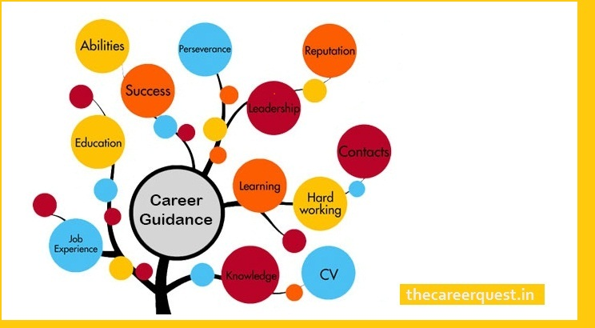

**ACTIVITY LOG FOR THE THIRD WEEK**

|  |  |  |  |
| --- | --- | --- | --- |
| Day & Date | Brief  Description of The Daily  Activity | Learning Outcome | Person  in Charge  Signature |
| MONDAY  &  12-06-23 | Why students need the career guidance | Learnt about career guidance |  |
| TUESDAY  &  13-06-23 | Why students need the career guidance | Learnt about career guidance |  |
| WEDNESDAY  &  14-06-23 | Why students need the career guidance | Learnt about career guidance |  |
| THURSDAY  &  15-06-23 | How career guidance helps students | Need of a good a  counselling |  |
| FRIDAY  &  16-06-23 | How career guidance helps students | Need of a good a  counselling |  |
| SATURDAY  &  17-06-23 | How career guidance helps students | Need of a good a  counselling |  |

**CHAPTER-4 ACTIVITY LOGBOOK ACTIVITY LOG FOR THE THIRD WEEK**

## WEEK 3 (From Dt:12-06-23 To Dt:17-06-23)

**Objective of activity done:**

The overall objective of the activities conducted during the Third week was to explain students about the necessity of career guidance and how the guidance can help the students for a better view of their future

**Detailed report:**

In the third week of the community service project on the very first day our team explained students about the need of a career guidance and how does career guidance help the students to build their future career. And try to explain students about the need of a career guidance and why a student need career guidance.

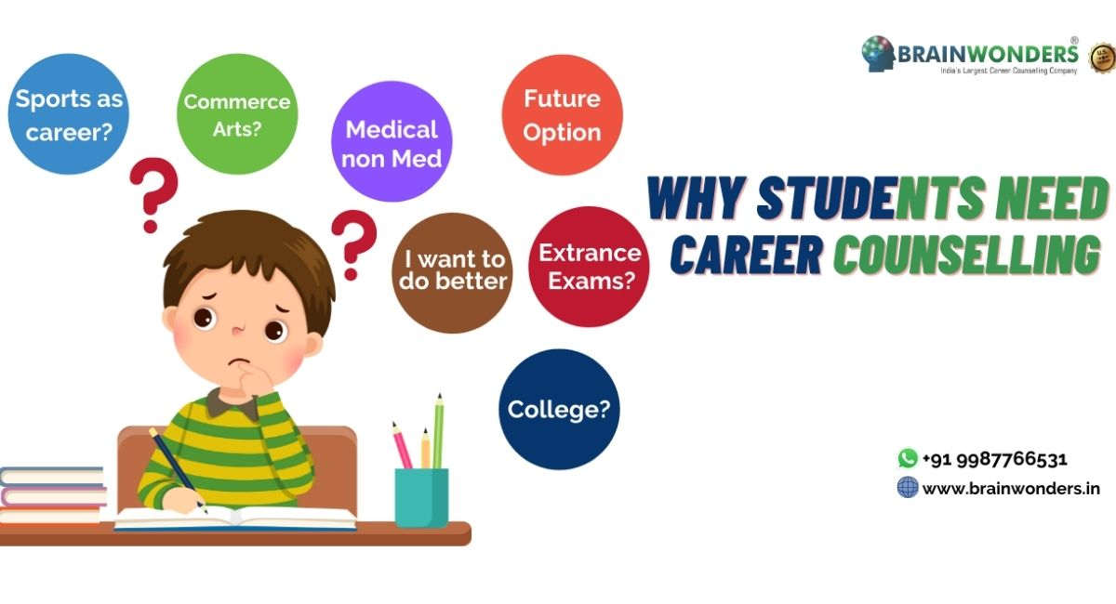

**ACTIVITY LOG FOR THE FOURTH WEEK**

|  |  |  |  |
| --- | --- | --- | --- |
| **Day & Date** | **Brief**  **Description of The Daily**  **Activity** | **Learning Outcome** | **Person**  **in Charge**  **Signature** |
| **MONDAY**  **&**  **19-06-23** | Importance of career  Guidance among students | Knowledge on career  path |  |
| **TUESDAY**  **&** | Importance of career  Guidance among students | Knowledge on career  path |  |
| **20-06-23** |  |  |  |
| **WEDNESDAY**  & | Importance of career  Guidance among students | Knowledge on career  path |  |
| **21-06-23** |  |  |  |
| **THURSDAY**  **&**  **22-06-23** | Secondary education boards a students can choose | Knowledge about the government exams |  |
| **FRIDAY**  **&**  **23-06-23** | Secondary education boards a students can choose | Knowledge about the government exams |  |
| **SATURDAY**  **&**  **24-06-23** | Secondary education boards a students can choose | Knowledge about the government exams |  |

**CHAPTER-4 ACTIVITY LOGBOOK ACTIVITY LOG FOR THE FOURTH WEEK**

## WEEK 4 (From Dt:19-06-23 To Dt:24-06-23)

**Objective of activity done:**

Through the activities conducted during the third week, students gained knowledge about the government education board for different course studies. Coming to the 4th week, students learned about the their possible

government examination boards they can join and importance of the career guidelines among students and how

it can help for the future development

**Detailed report:**

In the fourth week of the community service project students got the knowledge about the examination board after their completion of 10th standard and what are the various types of examinations they can take with their interested courses and also students learned about the importance of the career guidance to develop their future

On their interests and capability.

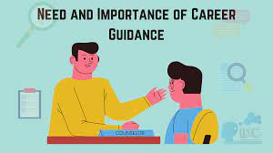

**ACTIVITY LOG FOR THE FIFTH WEEK**

|  |  |  |  |
| --- | --- | --- | --- |
| **Day & Date** | **Brief**  **Description of The Daily**  **Activity** | **Learning**  **Outcome** | **Person**  **In Charge**  **Signature** |
| **MONDAY**  **&**  **19-06-23** | Precautions needs to be taken | Precautions taken for better career path |  |
| **TUESDAY**  **&**  **20-06-23** | Precautions needs to be taken | Precautions taken for better career path |  |
| **WEDNESDAY**  **&**  **21-06-23** | Precautions needs to be taken | Precautions taken for better career path |  |
| **THURSDAY**  **&**  **22-06-23** | Precautions needs to be taken | Precautions taken for better career path |  |
| **FRIDAY**  **&**  **23-06-23** | Benefits of career guidance | Awareness on benefits of career guidance. |  |
| **SATURDAY**  **&**  **24-06-23** | Benefits of career guidance | Awareness on benefits of career guidance |  |

**CHAPTER-4 ACTIVITY LOGBOOK ACTIVITY LOG FOR THE FIFTH WEEK**

## WEEK 5 (From Dt:19-06-23 To Dt:24-06-23)

**Objective of activity done:**

The activities conducted during the fifth week of the community service project makes the people aware

the precautions to be taken, while choosing a career. During this week it learnt about precautions and benefits

while choosing a career.

**Detailed report:**

The fifth week of the community service we started the first day with the precautions that are to be taken for career guidance and how to take care while choosing a career and remaining three days we explained about the benefits of the career guidance and it helps students to choose their career

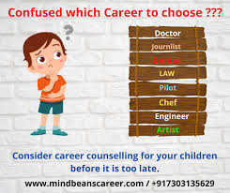

## CHAPTER 5: OUTCOMES DESCRIPTION

## 5.1. Learning Outcomes:

• Positive impact on students’ academic learning

• Improves students’ ability to apply what they have learned in “the real world”

• Improved ability to understand complexity and ambiguity Personal Outcomes

• Greater sense of personal efficacy, personal identity, spiritual growth, and moral development

• Positive impact on academic outcomes such as demonstrated complexity of understanding, problem analysis,

problem-solving, critical thinking, and cognitive development.

• Reduced stereotypes and greater inter-cultural understanding

• Improved social responsibility and citizenship skills

• Greater involvement in community service after graduation Career Development

• Connections with professionals and community members for learning and career opportunities

• Greater academic learning, leadership skills, and personal efficacy can lead to greater opportunity Relationship

with the Institution

• Stronger relationships with faculty

• Greater satisfaction with college

• Improved graduation rates

**5.2. BENEFITS OF COMMUNITY SERVICE PROJECT TO FACULTY MEMBERS**

• Satisfaction with the quality of student learning

• New avenues for research and publication via new relationships between faculty and community

• Providing networking opportunities with engaged faculty in other disciplines or institutions

• A stronger commitment to one’s research

**5.3. BENEFITS OF COMMUNITY SERVICE PROJECT TO COLLEGES**

**AND UNIVERSITIES**

• Improved institutional commitment

• Improved student retention

• Enhanced community relations

**5.4. BENEFITS OF COMMUNITY SERVICE PROJECT TO COMMUNITY**

• Satisfaction with student participation

• Valuable human resources needed to achieve community goals

• New energy, enthusiasm and perspectives applied to community work

• Enhanced community-university relations.

**5.5. ROLE OF STUDENTS:**

• Students may not have the expertise to conduct all the programmes on their own. The students then can play

a facilitator role and conduct the programmes involving Governmental agencies, non-Governmental agencies

or faculties of their college, etc.

• For conducting special camps like Health related, they will be coordinating with the Governmental agencies.

• As and when required the College faculty themselves act as Resource Persons.

• Students can work in close association with Non-Governmental Organizations like Lions Club, Rotary Club,

etc or with any NGO actively working in that habitation

• And also, with the Governmental Departments. If the programme is rolled out, the District Administration

could be roped in for the successful deployment of the programme.

• An in-house training and induction programme could be arranged for the faculty and participating students,

# 5.6. Personal Outcomes:

Participating in a community service project focused on career building guidance awareness can lead to various

various personal outcomes for individuals involved. Some potential personal outcomes include:

**5.7. Increased Empathy and Compassion:**

Engaging with students has taught me the problems of the choosing for choosing their career. And also, I have known that different students have many different ideas and many interests.

**5.8. personal Growth and Development:**

Involvement in a community service project provides opportunities for personal growth and development. It

can enhance one's leadership skills, communication abilities, and problem-solving capabilities. Engaging with

diverse individuals and collaborating on initiatives help develop adaptability and resilience, contributing to

personal growth.

**5.9. Expanded Knowledge and Understanding:**

Participating in this project has gained me much knowledge about the all-different courses. That are available

after 10th class and what are the outcomes of those courses and all the career paths we can take after our 10th

standard. I increased a lot of knowledge about secondary education and problems faced by student’s while

choosing course after 10th.

**5.10. Sense of Fulfilment and Purpose:**

By giving awareness about the career path choosing, we get a lot of satisfaction. Career guidance is important

for students who is having lack of knowledge and for students who wants to build their future in a successful

way. Purpose of this awareness educate the high school students to choose a good career which is suitable for

them.

**5.11. Enhanced Civic Responsibility:**

Engaging in community service projects like career building guidelines cultivates a sense of civic responsibility.

Participants develop a heightened awareness of their role as active citizens, recognizing responsibility. Their

ability to contribute to the betterment of their community and society as a whole. Students know about the

Importance of choosing a right career with good consultancy.

**5.12. Increased Self-Efficacy:**

Participating in Career guidelines awareness activities can enhance individuals' self- efficacy, the belief in

their ability to make a difference. By actively engaging in education, advocacy, and outreach efforts, individuals to develop a sense of confidence through their capacity.

**5.13. Lifelong Commitment to Giving Back:**

Engaging in career guidelines awareness can in still a lifelong commitment to giving back to the community

and local schools’ students. Participants may develop a sustained dedication to students’ bright career and future,

actively promoting awareness, and serving as advocates for this cause in their personals.

**5.14. Social Outcomes:**

Engaging in a community service project focused on career guidance this awareness can lead to various social

outcomes, benefiting both individuals and the community students.

Working towards a common goal of promoting on career guidance can strengthen social bonds within the com-

munity. By participating in activities together, community members develop relationships, forge new connect-

ions, and enhance a sense of togetherness and solidarity.

**5.15. Enhanced career Guidance:**

Career Guidance is an important factor for the students who are in their high school. Students has to be educated

about all the paths they can choose after their high school. Cause this is an important stage in your academic

journey as you begin to make decisions about your future career path.

**5.16. Career development:**

**A. Improved Communication Skills**:

Engaging in community outreach activities hones communication abilities, including public speaking and

presenting information effectively.

**B. Expanded Network**:

Collaborating with diverse individuals and organizations within the project fosters networking opportunities

and potential professional connections.

**C.** **Leadership Experience**:

Taking on roles and responsibilities within the project develops leadership skills and demonstrate initiative and

Organizational abilities.

**E**. **Enhanced Problem-Solving Abilities**:

Overcoming challenges and finding solutions during the project cultivates critical thinking and problem-solving

skills. These career development outcomes demonstrate the valuable experiences and skills individuals can gain

through their involvement in a milk production awareness community service project.

**5.17. Relationship with the Institution:**

1. **Institution Support**:

The institution plays a crucial role in supporting and facilitating the community service project. They provide

guidance, resources, and logistical assistance to ensure the project's success.

1. **Collaborative Efforts:**

The project provides an opportunity for collaboration between participants and the institution. Working together

towards a common goal strengthens the bond and fosters a sense of shared purpose and commitment.

1. **Institutional Recognition:**

The institution recognizes and acknowledges the efforts of participants in engaging in the community service

project. This recognition can take various forms, such as certificates, awards, or appreciation letters, which

which further strengthen the relationship between participants and the institution.

1. **Skill Development**:

Engaging in the project allows participants to enhance their skills and acquire new ones. The institution’s supp-

ort in providing training, mentorship, and resources contributes to the participants' skill development and over-

all growth.

**SURVEY QUESTIONS:**

1.Are there any job /roles which you are interested in as a future career?

2.Do you know what you would need to do to have a career in this field?

3.Are there any industries which you are interested in as a future career path?

4.Do you feel you understand the jobs which are available to you in the world today?

5.Are there any industries which you feel you do not understand?

6.Are there any industries which you feel you do not belong in?

7.Are there any industries you want to learn more about?

8.What would you like to see more of in school/college?

9.Do you understand how your subjects will relate to future job opportunities?

10.Are you aware of where to go to learn more about career?

11.Are you comfortable speaking in front of a group of people?

12.Can you list your strengths related to the skills you possess?

13.What skills would you like to build?

14.What skill have you acquired?

15.Do you feel that you are in control of your career path and that you are progressing in both your personal and professional development at this company?

16.Is your promotion and career path clear to you?

17.Do you understand the criteria that you need to meet to be promoted?

18.Do you feel challenged at work daily?

19.How many opportunities do you have for professional growth in this organisation?

20.How satisfied are you with the chances for promotion?

21.How likely are you to continue your career with this organisation?

22.Do you think the organisation provides professional development apart from career opportunities?

23.What other opportunities can the company provides you to develop your professional path?

24.In terms of professional development, what would you like the organisation to arrange?

25.How well do you feel you're fulfilling your role?

26.Do you think your organization provides you with a good level of job security?

27.How satisfied are you with the chances for promotion?

28.Is your promotion and career path clear to you?

29.Does the organization allow you to sharpen your professional skills?

30.What additional training or education will help you do better at your job?

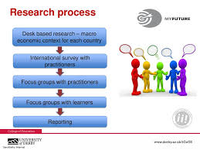

## Problems Identified in that Community

During the community assessment conducted for the awareness on career guidance, several problems and

Challenges were identified. These include:

**Lack of Knowledge:**

Many community members have a limited knowledge about the courses available they know only limited courses but not all courses, including its importance, process, and eligibility criteria.

**Poor knowledge about what to choose after 10th:**

You have to make very crucial decisions regarding your streams as you have to choose between science, comm-

erce, and arts. This will decide your career option and thus it will accordingly shape up your entire future. In

that respect career guidance after 10th becomes quite important. It not only helps in determining the right career

options but also the right career path. Career Counselling platforms offers you the opportunity to communicate

with the best **career counsellors** and understand what’s appropriate for you after 10th.

**Limited career counselling:**

Inadequate or unavailable career counselling in schools can leave students without proper guidance to make

informed decisions about their future career paths.

**Pressure to choose traditional careers:**

In certain societies or cultures, there might be an undue emphasis on traditional career paths such as engineering

medicine, or law, leading students to choose these paths even if they are not passionate about them.

**Limited exposure to non-academic careers:**

Not all students may have exposure to non-academic or vocational career options, leading to a skewed percept-

ion, that academic careers are the only viable choices.

**Financial constraints:**

Some career choices might require higher education or specialized training, which could be financially challen-

ging for certain students and their families.

**Changing job market:**

The job market is continuously evolving, and some career choices that may have been popular in the past might

become less in demand in the future.

**Parental influence:**

Parental pressure or influence can sometimes lead students to pursue careers that align with their parents'

aspirations rather than their own interests and talents.

**Regional disparities:**

Career opportunities and available guidance may vary significantly based on the region or location of the school,

with rural areas often having fewer resources.

**Lack of self-awareness:**

Some students may not fully understand their own interests, strengths, and weaknesses, making it challenging

for them to make well-informed career decisions. To address these problems, it is crucial to improve career

counselling services in schools, provide exposure to a wide range of career options, and promote the develop-

ment of both academic and practical skills. Additionally, there should be a shift in societal attitudes to recog-

nize and value diverse career choices and allow students the freedom to pursue their passions and interests.

**In light of these challenges, we propose the following solutions to address**

**and overcome these problems within our community:**

1. **Strengthen Career Counselling Services:**

Schools and educational institutions should invest in comprehensive and well-structured career counselling

services. Trained counsellors can guide students through various career options, assess their interests and

aptitudes, and help them make informed decisions about their future.

1. **Introduce Career Workshops and Seminars:**

Organize workshops, seminars, and career fairs that expose students to a diverse range of career opportunities.

Inviting professionals from different fields to share their experiences can inspire students and broaden their

horizons.

**Encourage Skill Development:**

Along with academic education, emphasize the development of practical skills. Offer vocational training programs and extracurricular activities that align with students' interests, talents, and potential career paths.

**Promote Awareness Campaigns:**

Launch awareness campaigns for students and parents, highlighting the various career options available after

the 10th grades. Share success stories of individuals who have pursued non-conventional careers to break the

stereotypes.

**Engage Parents and Guardians**:

Involve parents and guardians in the career counselling process. Help them understand the importance of allow

their children to choose careers based on their passions and abilities rather than societal pressures.

**Collaborate with Industry Experts:**

Partner with industry experts and professionals to provide real-world insights into various careers. Offer intern-

ship opportunities and mentoring programs to help students gain practical exposure.

**Upgrade Curriculum:**

Review and update the curriculum to include practical skill-building components and relevant information about

career options. Encourage project-based learning to promote critical thinking and problem-solving skills.

**Provide Scholarships and Financial Aid:**

Offer scholarships, grants, or financial aid to support students who have the talent and passion for specific

careers but face financial constraints in pursuing further education or training.

**Establish Career Resource Centres:**

Set up dedicated career resource centres in schools and colleges, providing access to relevant information,

books, online resources, and career-related workshops.

**Collaborate with Government Initiatives:**

Encourage partnerships with government initiatives that aim to promote vocational training, entrepreneurship,

and skill development among young individuals.

**Monitor and Evaluate Progress:**

Regularly assess the effectiveness of career counselling programs and initiatives. Collect feedback from

students, parents, and educators to make improvements and adaptations as needed.

By implementing these strategies, we can create a more conducive environment for students to explore their

career options and make informed decisions about their future paths after the 10th grade. Additionally,

promoting a more inclusive and open-minded approach towards career

choices will benefit both students and society as a whole.

**SHORT TERM AND LONG-TERM ACTION PLAN FOR POSSIBLE**

**SOLUTIONS**

**Short-Term Action Plan:**

Immediate Training for School Counsellors: Conduct specialized training workshops for school counsellors to equip them with the necessary skills and resources to provide effective career guidance to students.

**Career Seminars and Workshops:**

Organize career seminars and workshops in schools to expose students to a wide range of career options and help them understand the skills required for each path.

**Online Career Assessment Tools:**

Introduce online career assessment tools that students can access to explore their interests, strengths, and potential career matches.

**Industry Expert Webinars:**

Arrange webinars where professionals from diverse fields share their experiences, challenges, and successes to inspire and inform students about various career choices.

**Parental Involvement Sessions**:

Conduct sessions for parents and guardians to educate them about the importance of supporting their

children's career choices based on interests and aptitudes.

**Career Resource Centre:**

Set up a career resource centre in schools with books, brochures, and online resources related to different

career paths, higher education options, and scholarships.

**Collaboration with Local Industries:**

Establish partnerships with local industries to provide students with exposure to practical experiences through

field visits or internships.

**Skill Development Workshops:**

Offer short-term skill development workshops during vacations to help students acquire practical skills relevant

to their career interests.

**Awareness Campaigns:**

Run awareness campaigns within the school and local community to break stereotypes about certain careers

and promote the importance of individual interests and passions.

**Feedback Mechanism:**

Implement a feedback system where students can provide their opinions and suggestions on the effectiveness

of career guidance programs.

**Long-Term Action Plan:**

**Comprehensive Career Education Curriculum:**

Develop a comprehensive career education curriculum integrated into the school system from an early stage,

starting in primary education.

**Qualified Career Counselling Professionals:**

Work towards having dedicated and qualified career counsellors in every educational institution to provide

personalized guidance to students.

**Skill-Oriented Academic Approach:**

Revise the academic approach to include more skill-oriented learning and practical experiences to prepare

students for their future careers.

**Government Policies and Support:**

Advocate for government policies that promote career education, vocational training, and financial aid for

students pursuing various career paths.

**Industry-Academia Collaboration:**

Strengthen partnerships between educational institutions and industries to align the curriculum with industry

needs and trends.

**Virtual Career Guidance Platforms:**

Develop online platforms that offer virtual career guidance, job-shadowing opportunities, and mentorship

programs to reach students beyond their immediate surroundings.

**Career Expos and Fairs:**

Organize larger-scale career expos and fairs at the city or regional level to bring together students, parents,

educational institutions, and employers.

**Alumni Engagement:**

Involve alumni networks to share their career journeys and offer mentorship support to current students.

**Scholarship and Financial Assistance Programs:**

Establish more scholarship and financial assistance programs to support students from economically disadvant-

-aged backgrounds in pursuing their chosen careers.

**Continued Evaluation and Improvement:**

Regularly evaluate the effectiveness of the career guidance initiatives, seeking input from all stakeholders, and

make continuous improvements to ensure their relevance and impact.

By combining short-term actions to address immediate needs and long-term strategies for sustained improve-

ment, we can build a more robust career guidance system that empowers students to make informed decisions

about their future after the 10th grade.

**REPORT OF THE COMMUNITY SERVICE PROJECT DONE IN THE**

**RELATED SUBJECT W.R.T THE HABITATION/VILLAGE.**

**INTRODUCTION:**

The community service project focused on raising awareness about Career Guidance in our habitation/village

aimed to address the lack of knowledge and understanding regarding the importance of career building. Career

Guidance is an important aspect in every 10th student life it helps to build a good career for students and

improves knowledge among students.

**PROJECT ACTIVITIES:**

Designing a project for career building guidance requires careful planning and execution. Below are some

project activities that can be included in a comprehensive career guidance initiative

**Needs Assessment:**

Conduct a thorough needs assessment to understand the specific career guidance requirements of the target

audience (e.g., 10th-grade students). Gather data through surveys, interviews, and focus groups to identify their

interests, aspirations, and challenges.

**Resource Development:**

Create career resource materials such as brochures, handouts, and online guides that provide information on

various career options, educational pathways, and skill development opportunities.

**Career Counselling Workshops:**

Organize interactive workshops led by professional career counsellors. These workshops can cover topics like

self-assessment, goal setting, and exploration of different career paths.

**Career Seminars and Webinars:**

Invite professionals from diverse fields to conduct career seminars and webinars. This allows students to learn

about real-world experiences and gain insights into different career trajectories.

**Online Career Assessment Tools:**

Develop or adopt online career assessment tools that students can access to identify their strengths, interests,

and potential career matches.

**Industry Visits and Internships:**

Arrange visits to local industries and organizations, providing students with hands-on experiences and insights

into various career fields.

**Career Expos and Fairs:**

Host career expos and fairs where educational institutions, vocational training centres, and employers can

showcase opportunities and interact with students.

**Parental Involvement Sessions:**

Conduct sessions for parents and guardians to inform them about the importance of supporting their children’s

career choices and providing guidance throughout the decision-making process.

**Mentorship Programs:**

Establish mentorship programs, connecting students with professionals from their areas of interest. Mentors

can offer guidance, advice, and support as students navigate their career paths.

**Skill Development Workshops:**

Offer workshops focusing on essential skills like communication, problem-solving, and leadership, which are

valuable in various career fields.

**Online Career Guidance Platform:**

Develop an online platform that provides comprehensive career guidance resources, interactive tools, and

forums for students to engage with counsellors and peers.

**Career Success Stories:**

Share success stories of individuals who have pursued non-traditional career paths, inspiring students to explore

diverse possibilities.

**Alumni Engagement:**

Engage alumni to share their career journeys and experiences, providing valuable insights into the professional

world.

**Feedback and Evaluation:**

Regularly collect feedback from students, parents, and educators to evaluate the effectiveness of the project

activities and make improvements based on the input received.

**Collaboration with Educational Institutions:**

Collaborate with schools, colleges, and universities to integrate career guidance programs into their curricula

and ensure a sustainable impact

**CHAPTER 6: RECOMMENDATIONS & CONCLUSIONS OF THE**

**COMMUNITY SERVICE PROJECT**

**Recommendations:**

**6.1 Promote awareness:**

Develop a comprehensive awareness campaign to educate the students about the importance of career building

guidance.

**6.2 Organize Workshops and Training Sessions**:

Conduct workshops, seminars, and training sessions on various aspects of career guidance, including importance of career guidance, proper career guidance, how does career guidance help, and effective techniques for career guidance.

**6.3 Early Exposure:**

Start career guidance early in a student's academic journey, ideally in middle school, to help them explore

various career options and make informed decisions.

**6.4 Comprehensive Assessment:**

Utilize a combination of aptitude tests, personality assessments, and interest inventories to provide a holistic

view of a student's strengths and preferences.

**6.5 Personalized Guidance:**

Offer one-on-one counselling sessions to provide personalized guidance tailored to each student's unique

interests, goals, and circumstances.

**6.6 Practical Experiences:**

Facilitate internships, job-shadowing opportunities, and industry visits to give students a hands-on understanding of different careers.

**6.7 Mentorship Programs:**

Establish mentorship programs connecting students with professionals in their desired fields, allowing them

to learn from real-world experiences.

**6.8 Diverse Career Options:**

Showcase a wide range of career paths, including non-academic and vocational options, to help students

explore beyond traditional choices.

**Conclusion:**

**Increased community involvement:**

In conclusion, career building guidance after the 10th grade plays a pivotal role in shaping the future of students and preparing them for the challenges of the professional world. The period after the 10th grade marks a critical juncture when students face the task of selecting suitable career paths based on their interests, abilities, and aspirations. However, several challenges have been identified in this process, including the lack of awareness about diverse career options, limited access to quality counselling, parental and societal pressure, and inadequate skill development.

To overcome these obstacles, it is essential to adopt a multi-faceted approach that combines short-term and long-term solutions. Short-term measures, such as improving career counselling services in schools, organizing career workshops and seminars, and offering skill development programs, can provide immediate support to students. These activities can help broaden their horizons, inspire them to explore various careers, and gain practical insights into different professions.

For a lasting impact, a long-term action plan is vital. This may involve integrating comprehensive career education into the curriculum from an early stage, enhancing collaboration between educational institutions and industries, and advocating for government support and policies that promote career development initiatives.

Additionally, it is essential to involve parents and guardians in the process, fostering a supportive and understanding environment where students can freely explore their interests and passions.

By implementing these recommendations, career building guidance after the 10th grade can be transformed into a robust and inclusive system that empowers students to make well-informed decisions, equipping them with the skills and knowledge necessary to thrive in their chosen careers. Ultimately, effective career guidance not only benefits individual students but also contributes to the growth and prosperity of society as a whole.

**Evaluation by the Person in-charge in the Community/Habitation**

|  |
| --- |
| Student Name: Bommu Lakshmi Prasanna  Roll Number: 21471A0513  Term of CSP: Career Building Guidelines  Date of Evaluation: 24-06-23  Name of the Person in-charge: Dr. Jhansi Vazram.  Address: Narasaraopet, 522601.  Mobile Number: 7780543825 |

**Please rate your performance in the following areas:**

**Rating Scale: 1 is lowest and 5 is highest rank**

**1** Oral communication **1 2 3 4 5**

|  |  |  |  |  |  |  |  |
| --- | --- | --- | --- | --- | --- | --- | --- |
| **2** | Written communication |  | 1 | 2 | 3 | 4 | 5 |

**3** Proactiveness 1 2 3 4 5

|  |  |  |  |  |  |  |
| --- | --- | --- | --- | --- | --- | --- |
| **4** | Interaction ability with community | 1 | 2 | 3 | 4 | 5 |

**5** Positive Attitude 1 2 3 4 5

|  |  |  |  |  |  |  |  |  |  |
| --- | --- | --- | --- | --- | --- | --- | --- | --- | --- |
| **6** | Self Confidence |  |  |  | 1 | 2 | 3 | 4 | 5 |

**7** Ability to learn 1 2 3 4 5

|  |  |  |  |  |  |  |  |  |
| --- | --- | --- | --- | --- | --- | --- | --- | --- |
| **8** | Work Plan and organization |  |  | 1 | 2 | 3 | 4 | 5 |

**9** Professionalism 1 2 3 4 5

|  |  |  |  |  |  |  |  |  |  |
| --- | --- | --- | --- | --- | --- | --- | --- | --- | --- |
| **10** | Creativity |  |  |  | 1 | 2 | 3 | 4 | 5 |

**11** Quality of work done 1 2 3 4 5

|  |  |  |  |  |  |  |  |  |
| --- | --- | --- | --- | --- | --- | --- | --- | --- |
| **12** | Time Management |  |  | 1 | 2 | 3 | 4 | 5 |

**13** Understanding the Community 1 2 3 4 5

|  |  |  |  |  |  |  |
| --- | --- | --- | --- | --- | --- | --- |
| **14** | Achievement of Desired Outcomes | 1 | 2 | 3 | 4 | 5 |

**15** OVERALL PERFORMANCE 1 2 3 4 5

**Date:** Signature of the Student

**Evaluation by the Person in-charge in the Community/Habitation**

|  |
| --- |
| Student Name: Bommu Lakshmi Prasanna  Roll Number: 21471A0513  Term of CSP: Career Building Guidelines  Date of Evaluation: 24-06-2023  Name of the Person in-charge: Dr. Jhansi Vazram  Address: Narasaraopet, 522601.  Mobile Number: 7780543825 |

Please rate Student’s performance in the following areas:

Please note that your evaluation shall be done independent of the student’s self- evaluation.

**Rating Scale: 1 is lowest and 5 is highest rank**

**1**  Oral communication **1 2 3 4 5**

|  |  |  |  |  |  |  |  |
| --- | --- | --- | --- | --- | --- | --- | --- |
| **2** | Written communication |  | 1 | 2 | 3 | 4 | 5 |

**3** Proactiveness 1 2 3 4 5

|  |  |  |  |  |  |  |
| --- | --- | --- | --- | --- | --- | --- |
| **4** | Interaction ability with community | 1 | 2 | 3 | 4 | 5 |

**5** Positive Attitude 1 2 3 4 5

|  |  |  |  |  |  |  |  |  |  |
| --- | --- | --- | --- | --- | --- | --- | --- | --- | --- |
| **6** | Self Confidence |  |  |  | 1 | 2 | 3 | 4 | 5 |

**7** Ability to learn 1 2 3 4 5

|  |  |  |  |  |  |  |  |  |
| --- | --- | --- | --- | --- | --- | --- | --- | --- |
| **8** | Work Plan and organization |  |  | 1 | 2 | 3 | 4 | 5 |

**9** Professionalism 1 2 3 4 5

|  |  |  |  |  |  |  |  |  |  |
| --- | --- | --- | --- | --- | --- | --- | --- | --- | --- |
| **10** | Creativity |  |  |  | 1 | 2 | 3 | 4 | 5 |

**11** Quality of work done 1 2 3 4 5

|  |  |  |  |  |  |  |  |  |
| --- | --- | --- | --- | --- | --- | --- | --- | --- |
| **12** | Time Management |  |  | 1 | 2 | 3 | 4 | 5 |

**13** Understanding the Community 1 2 3 4 5

|  |  |  |  |  |  |  |
| --- | --- | --- | --- | --- | --- | --- |
| **14** | Achievement of Desired Outcomes | 1 | 2 | 3 | 4 | 5 |

**15** OVERALL PERFORMANCE 1 2 3 4 5

**Date: Signature of the supervisor**

**PHOTOS OF OUR PROJECT CAREER GUIDANCE**

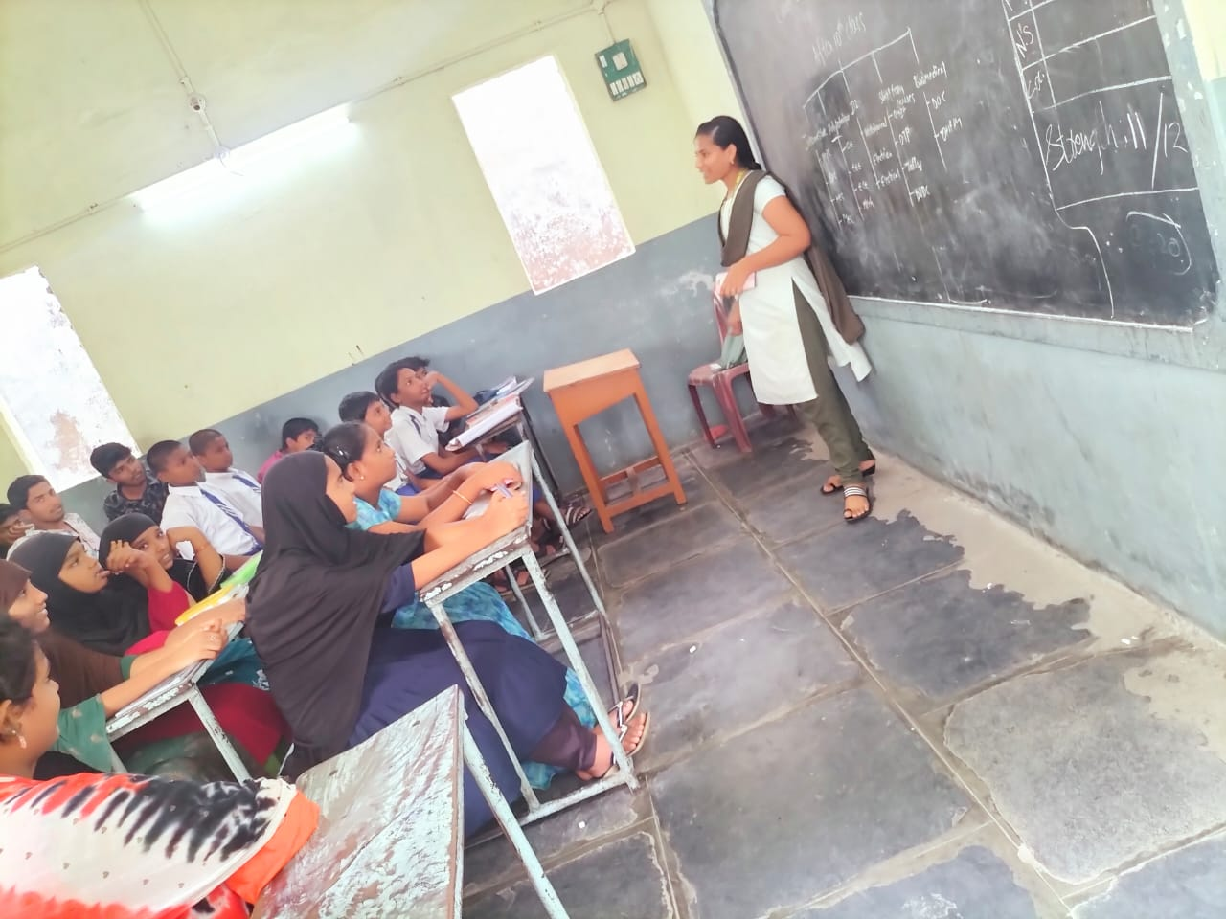

Collaborating with the students in Narasaraopet public school.

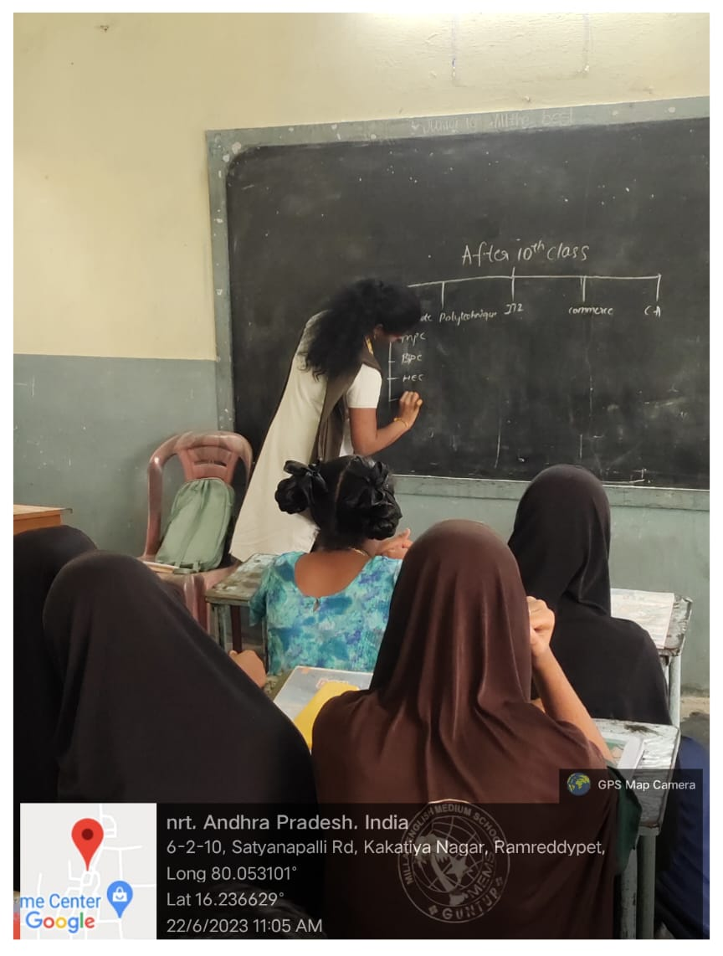

**.**

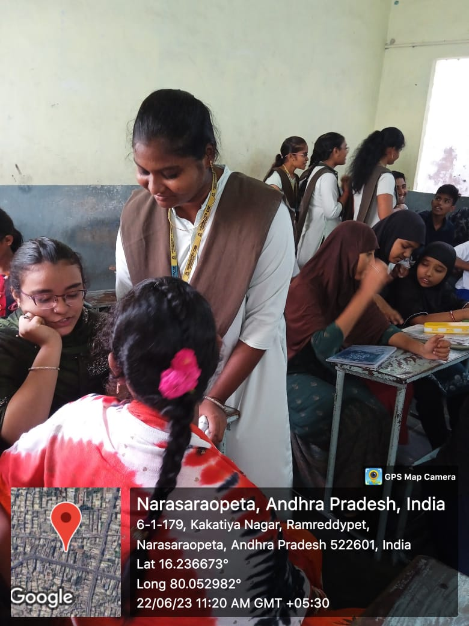

Interacting with students to know more about their interests

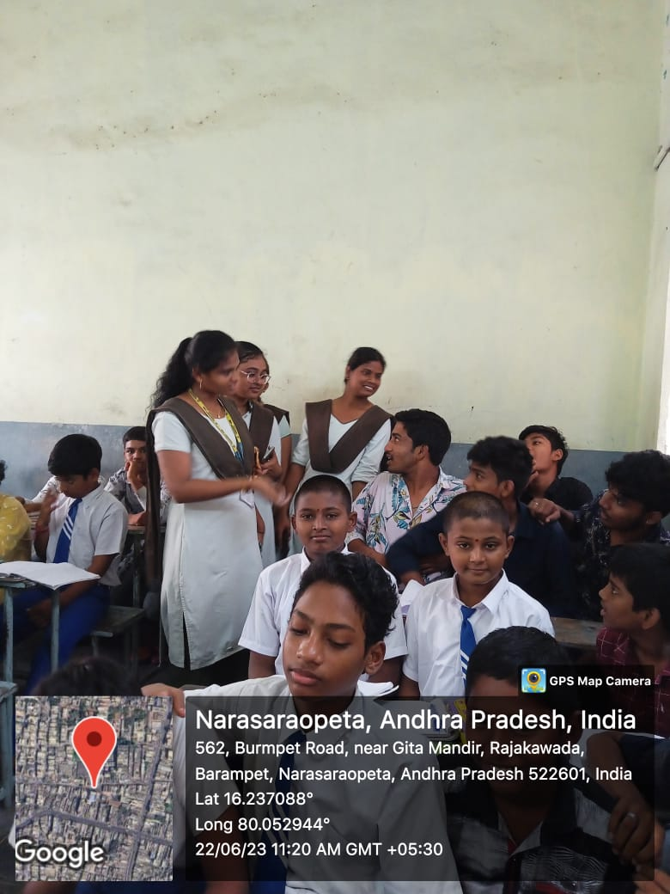

Interacting with students about the list of courses available after 10th

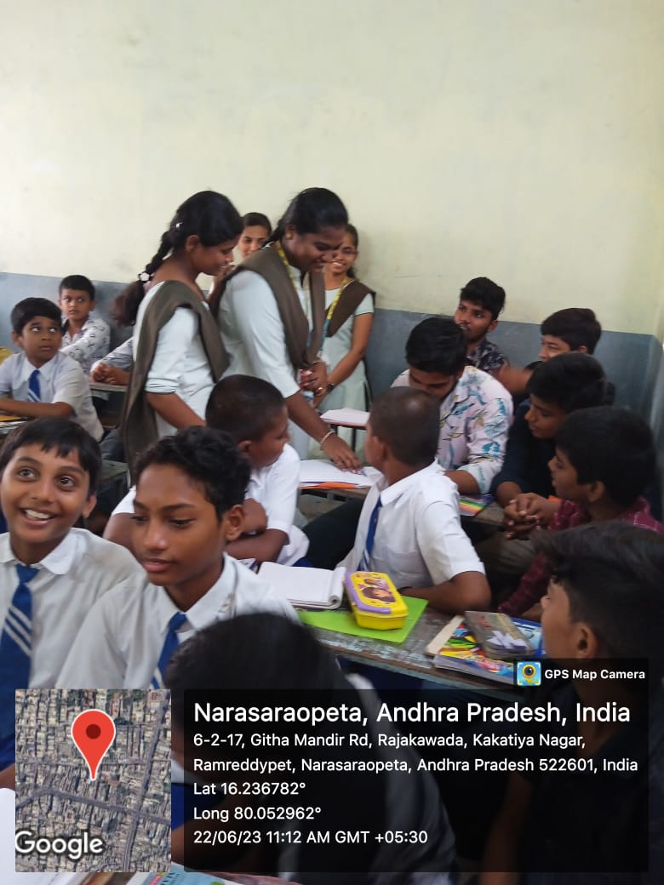

z

Interaction with students about their interests and guiding them what they wanted to do in their future about choosing a correct course.

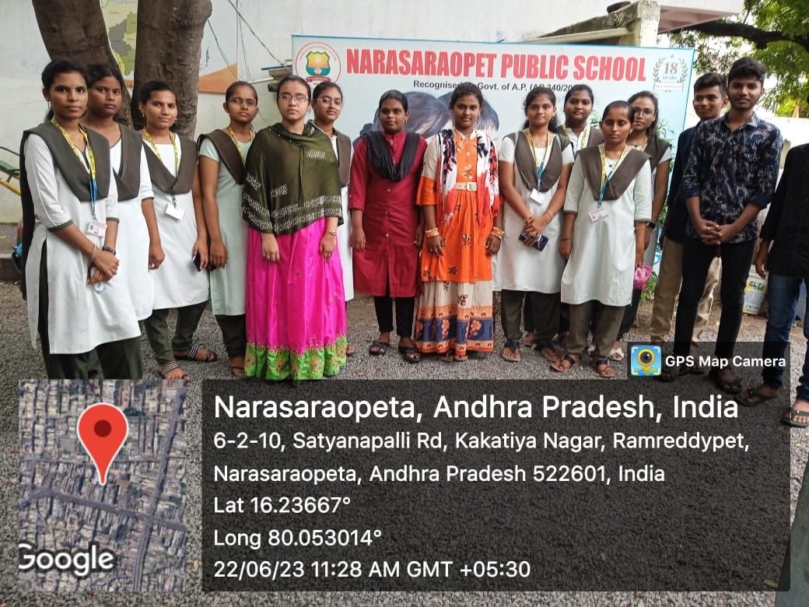

Pics with students in Narasaraopeta Public School

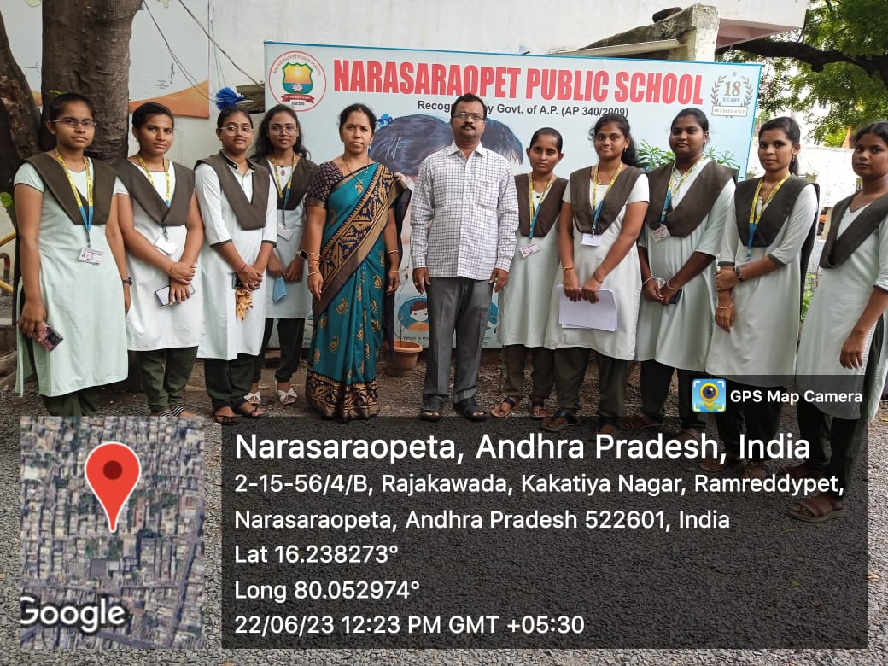

Pics with principal and Director of Narasaraopeta Public school

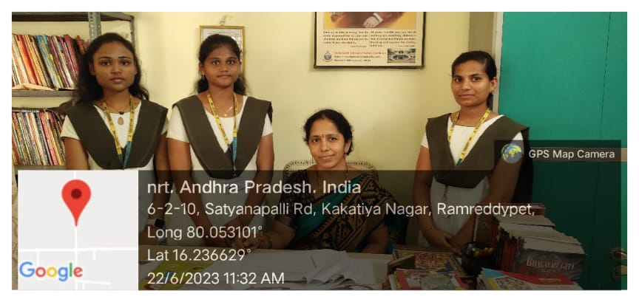

Pic with Director of Narasaraopet Public School

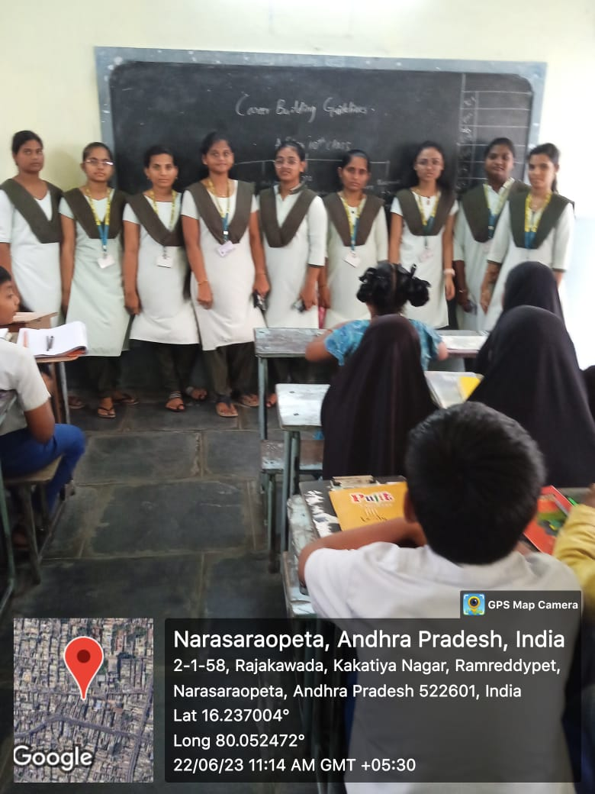

We did survey among 10th class students about career building guidelines

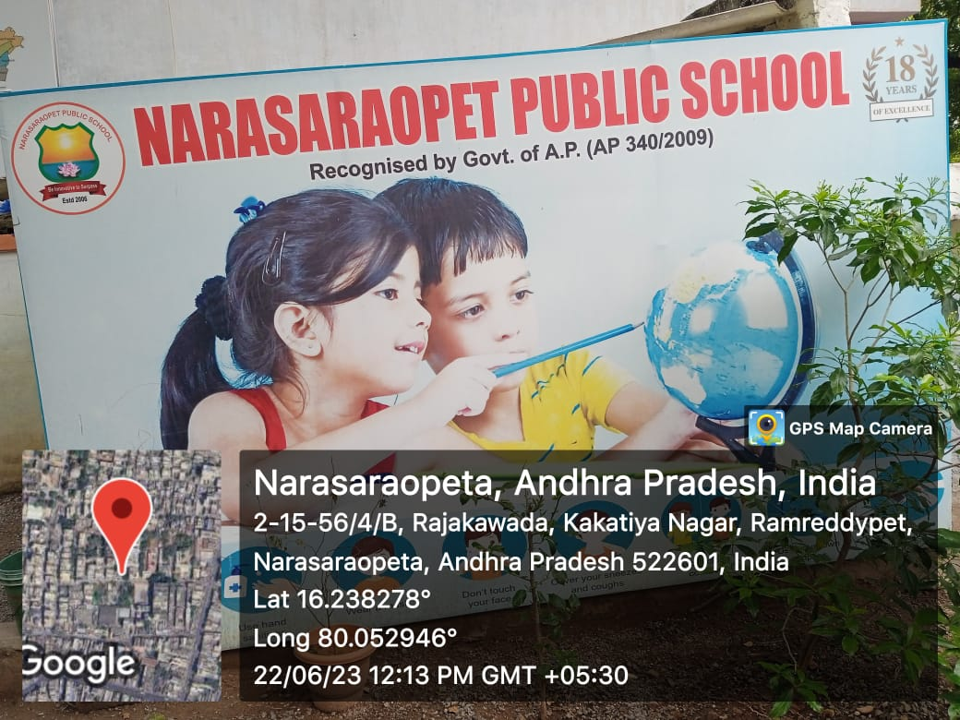

Images of the Narasaraopet public school and environment in the school.

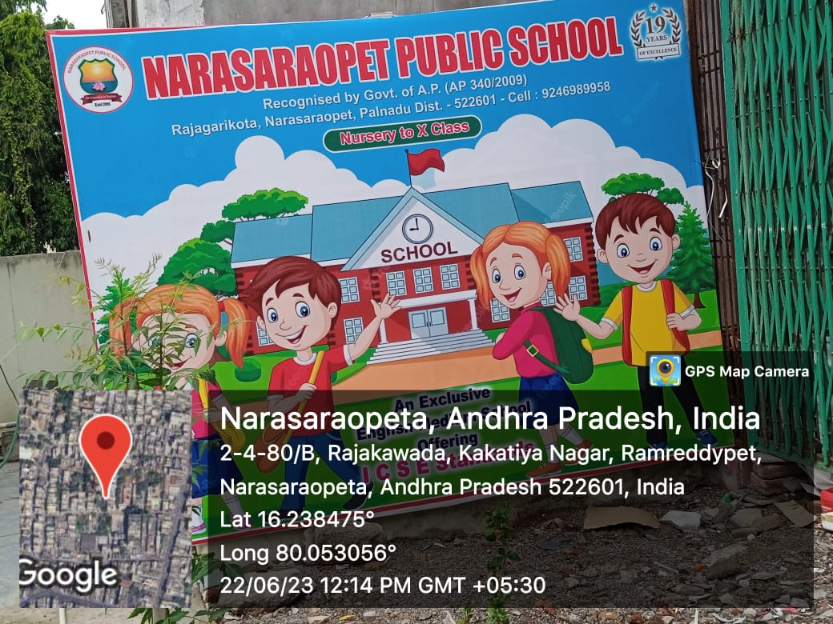

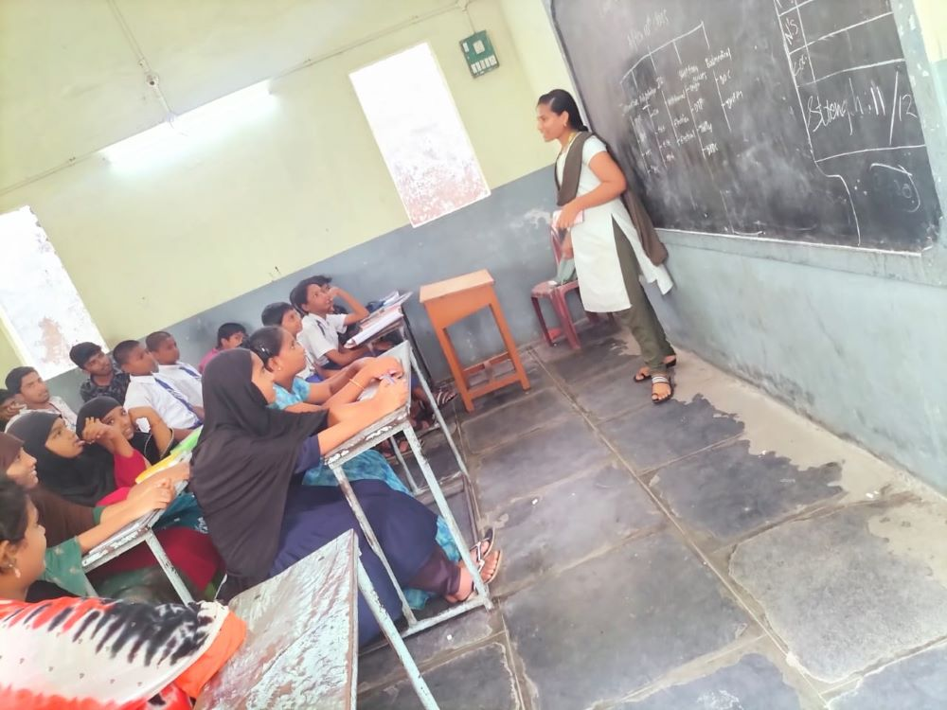

we have our survey at the Narasaraopet public school for our career guidance project

**SAMPLE IMAGES OF OUR WEBSITE**

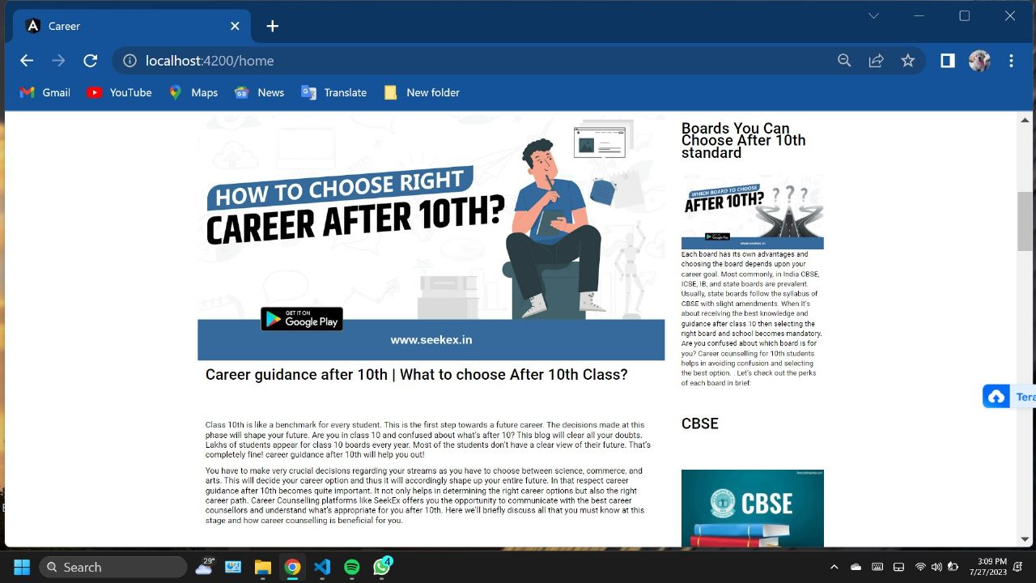

This is our website home page it has all info about the career guidance

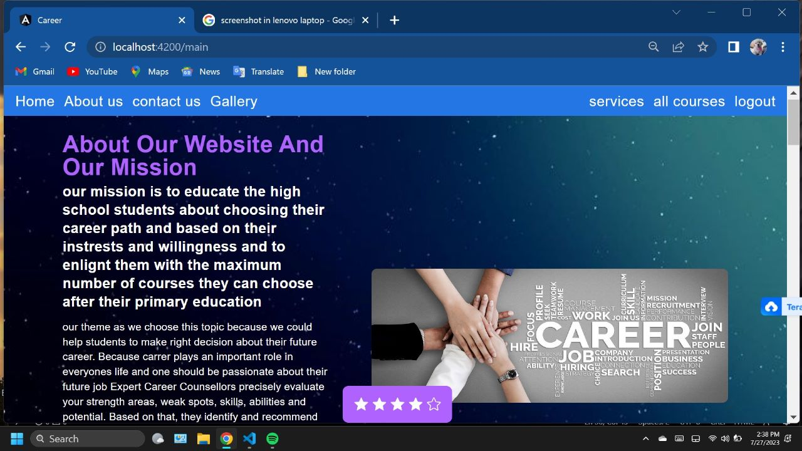

This is our about us page

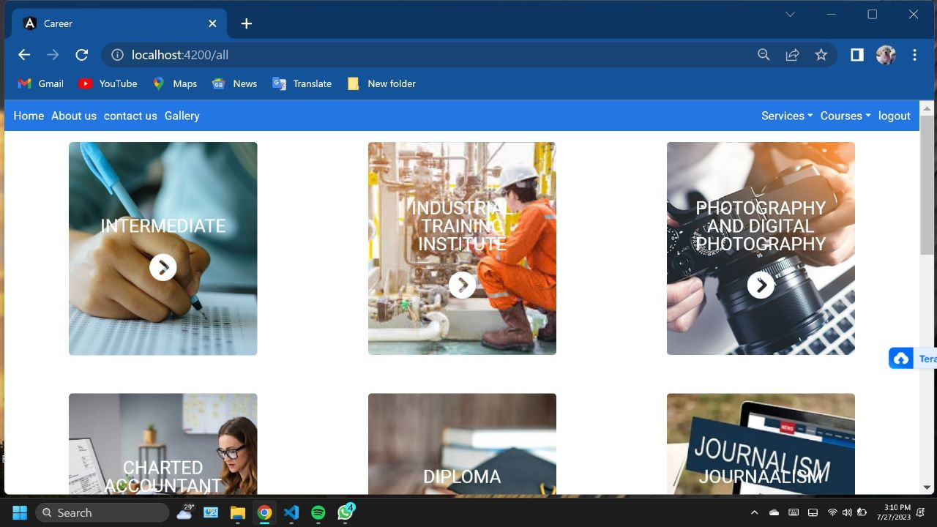

This page consists of all available courses after 10th standard

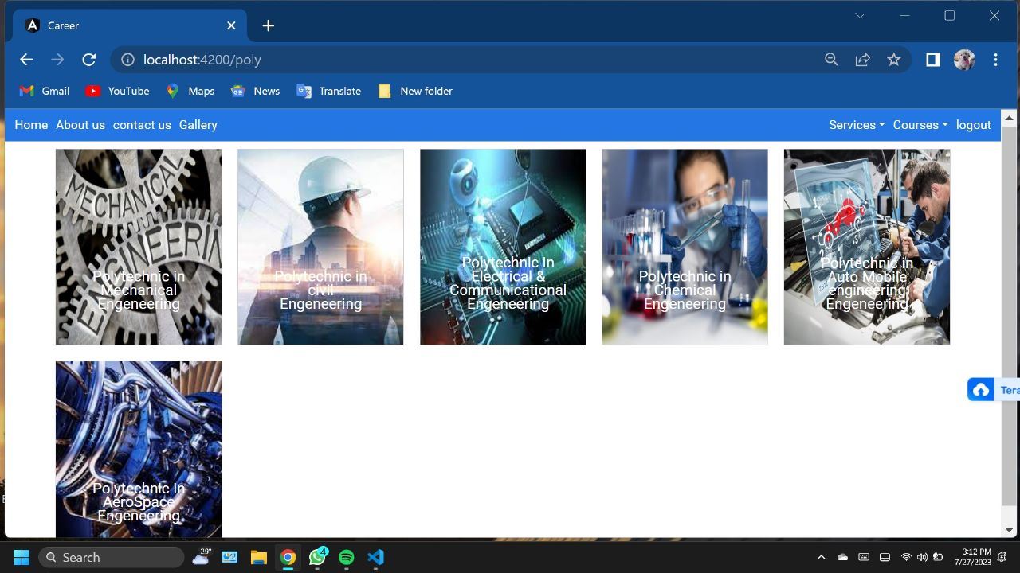

This is a sample page for the sub courses available in the course of polytechnic

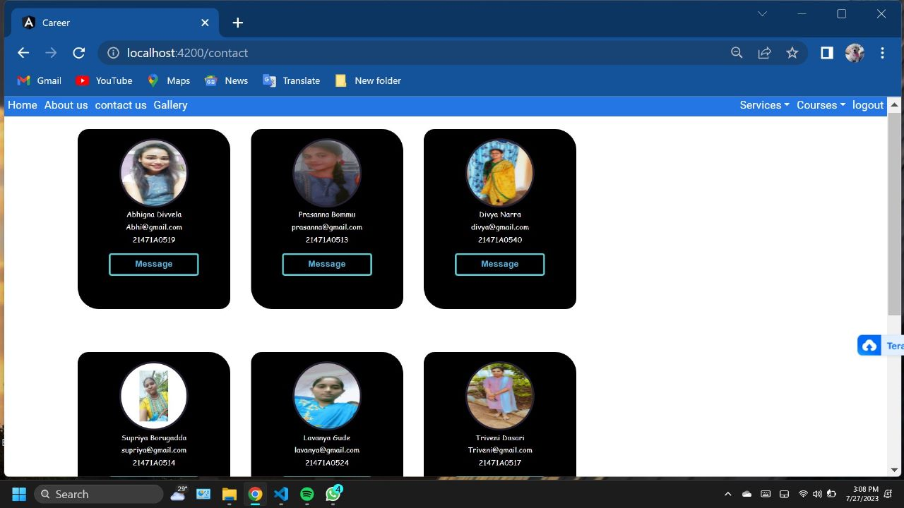

This is our contact page 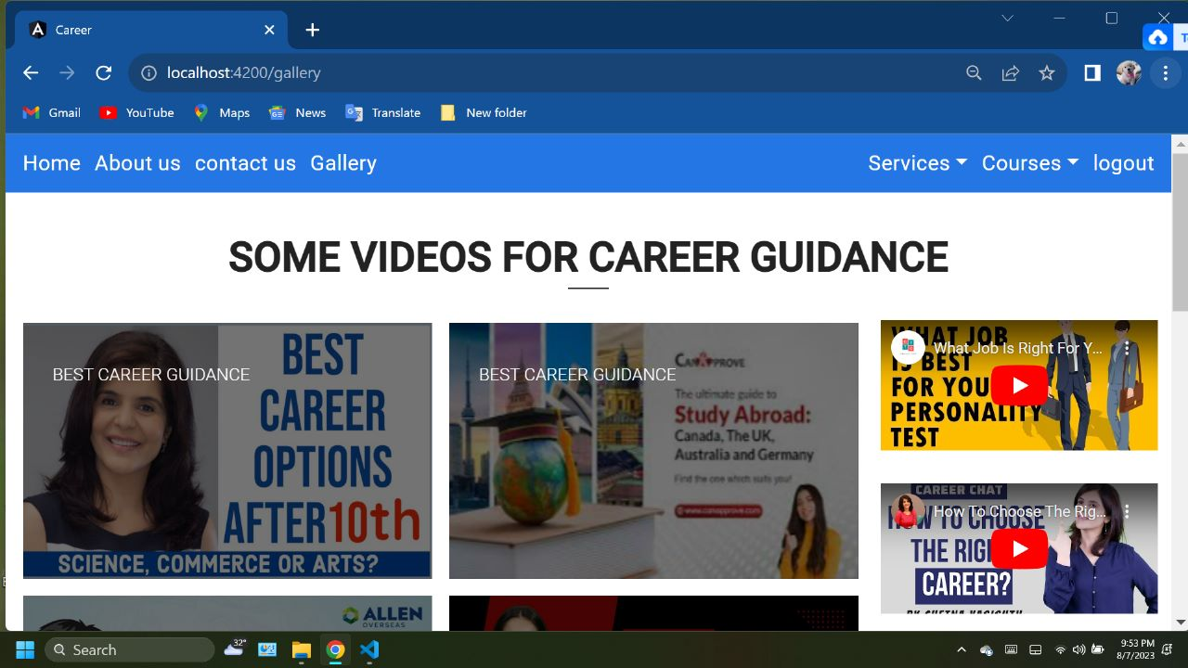

Some videos for career guidance

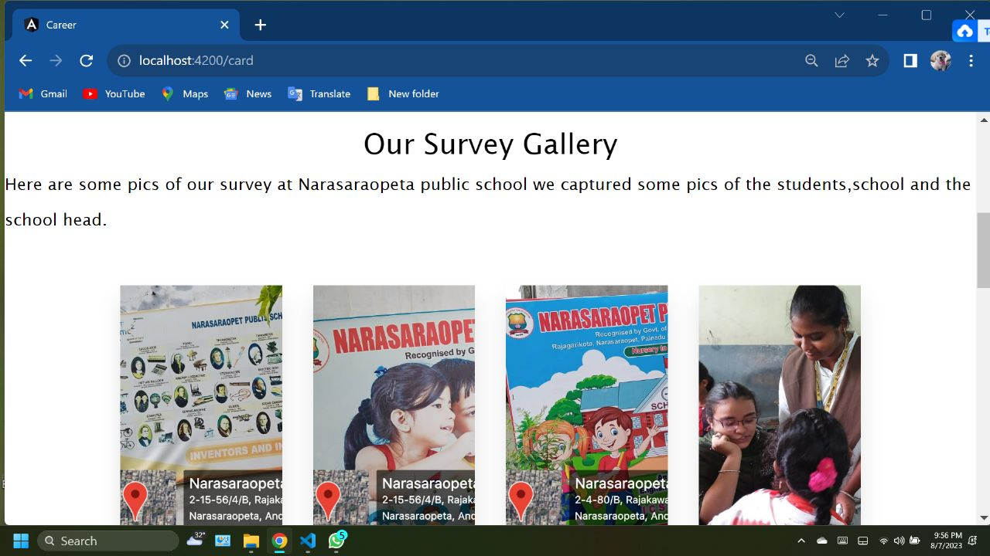

Gallery of our project

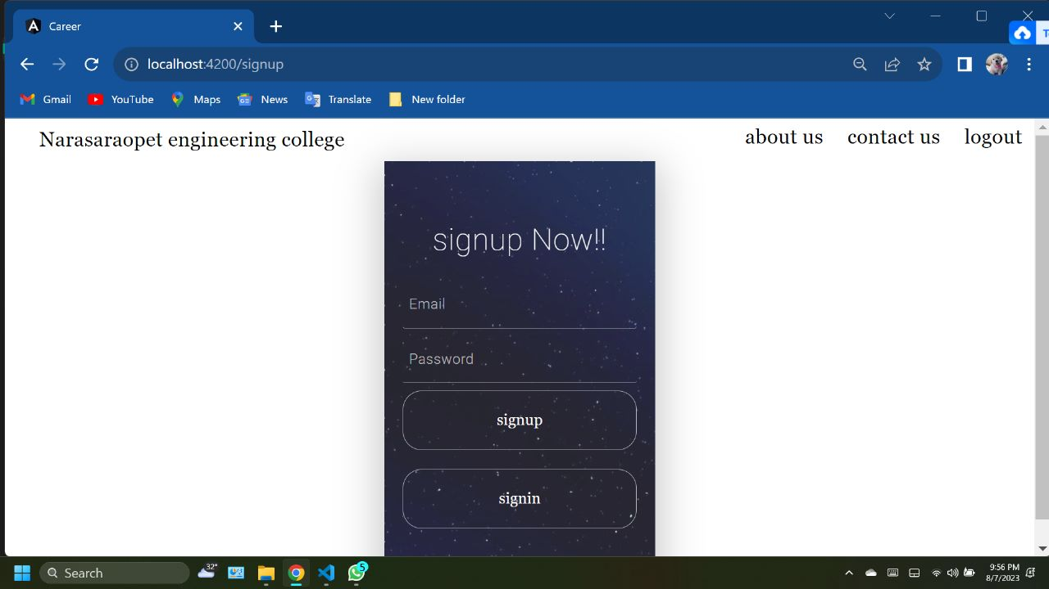

Login form of our project